European Partnership on Animal Health & Welfare (PAHW)

Les enjeux
- AH&W a Global Public Good
- Livestock play a major economic role (€168 billion annually for EU)
- 20% of animal production loss due to animal diseases worldwide (OIE)
- Increasing threats from exotic diseases, notably vector-borne diseases
- Increasing rate of emergence of novel (zoonotic) pathogens; jumps between species (SARS, SARS-Cov2)
- Major crises disturbing trade and jeopardizing consumer confidence (BSE, ASF).
- One Health: Zoonoses and Antimicrobial resistance (AMR) are serious health threats
- Societal concerns about the conditions under which animal production takes place and the level of animal welfare

Vision of the Partnership
- Provide society with reassurance on the control of infectious animal diseases with appropriate means, where
antimicrobials are prudently used, where animal welfare is respected and improved, thus contributing to sustainable livestock farming and the protection of public health and the environment.
This vision and ambition will be achieved through strengthened cooperation between public research and innovation entities, and the association of relevant partners, including the animal health industry.

4 Working Groups on ‘What’ (themes, activities), to feed into PAHW Dossier + SRIA
WG Surveillance: Y Van der Stede (EFSA) and W van der Poel (EPIZONE)
WG Diagnostics: P Jokelainen (OHEJP) and M Beer (CWG)
WG Farming Practices: K Möller (ICRAD, farming) and V Michel (Animal Welfare)
WG Treatment & Vaccines: S Arnouts (Industry perspective) and A Morrow (IRC)
Plus transversal working groups: WG AMR (see One Health EJP and JPIAMR): A Käsbohrer and R La Ragione (OHEJP); WG Fish (see SCAR Fish): M Bagni and G Arcangeli

Proposed mode of implementation

Research activities performed both through (mainly?) external, open calls, plus activities performed internally

- Open R&I calls
  - Aiming at generating knowledge, at including private partners in the research, e.g. to bring in new technologies for diagnostics or vaccine development etc., to facilitate uptake by industry (higher TRL)
  - Or in case additional expertise is needed but not available in the partnership consortium
  - Organized by Funding Organizations (in cash funding, EC co-funding possible)
  - All infectious diseases, both basic and applied research

- Internal R&I calls

- Reinforce cooperation among research centres, reference laboratories/centres, with specific mandates (e.g. regulated diseases and AMR; reference activities), or special experimental facilities; mainly integrative research (capacity building, data sharing and risk assessment); policy driven research (incl. animal welfare)
All are EC co-founded and partners contribute through in kind funding And other activities!

Other activities (other than research calls)
- Integrative activities focussing on the laboratories, risk assessment and risk management
- Capacity building: harmonization and standardization, proficiency testing, etc.
- Shared infrastructure, shared repositories, databases
- Other activities to strengthen the consortium:
  - Consultation meetings with stakeholders and interested parties
  - Education and training activities
  - Communication, dissemination and exploitation towards a broader audience, i.e., scientists, professionals, policy makers, other stakeholders, incl. consumers and citizens; to support uptake of outcome and to gain impact
These activities will have to be decided by the consortium, since some of them could also be organized in calls

Potential members and stakeholders:

    - Consortium members
        - Research Performing Organisations (RPO) working on regulated infectious animal diseases and animal welfare, with specific mandates (e.g. regulated diseases; reference activities), or with special experimental facilities; mainly for integrative research/non research activities (internal calls)
        - National and regional Funding Organisations (FO), to support external joint calls essentially for transnational research with RPO mainly outside PAHW but also within PAHW consortium

    - “Stakeholders” of different types:
        - RPO in projects selected via external open calls
        - Relevant industry partners (animal sector, diagnostics & pharmaceutics), to advise and to take part in research projects organised through external calls
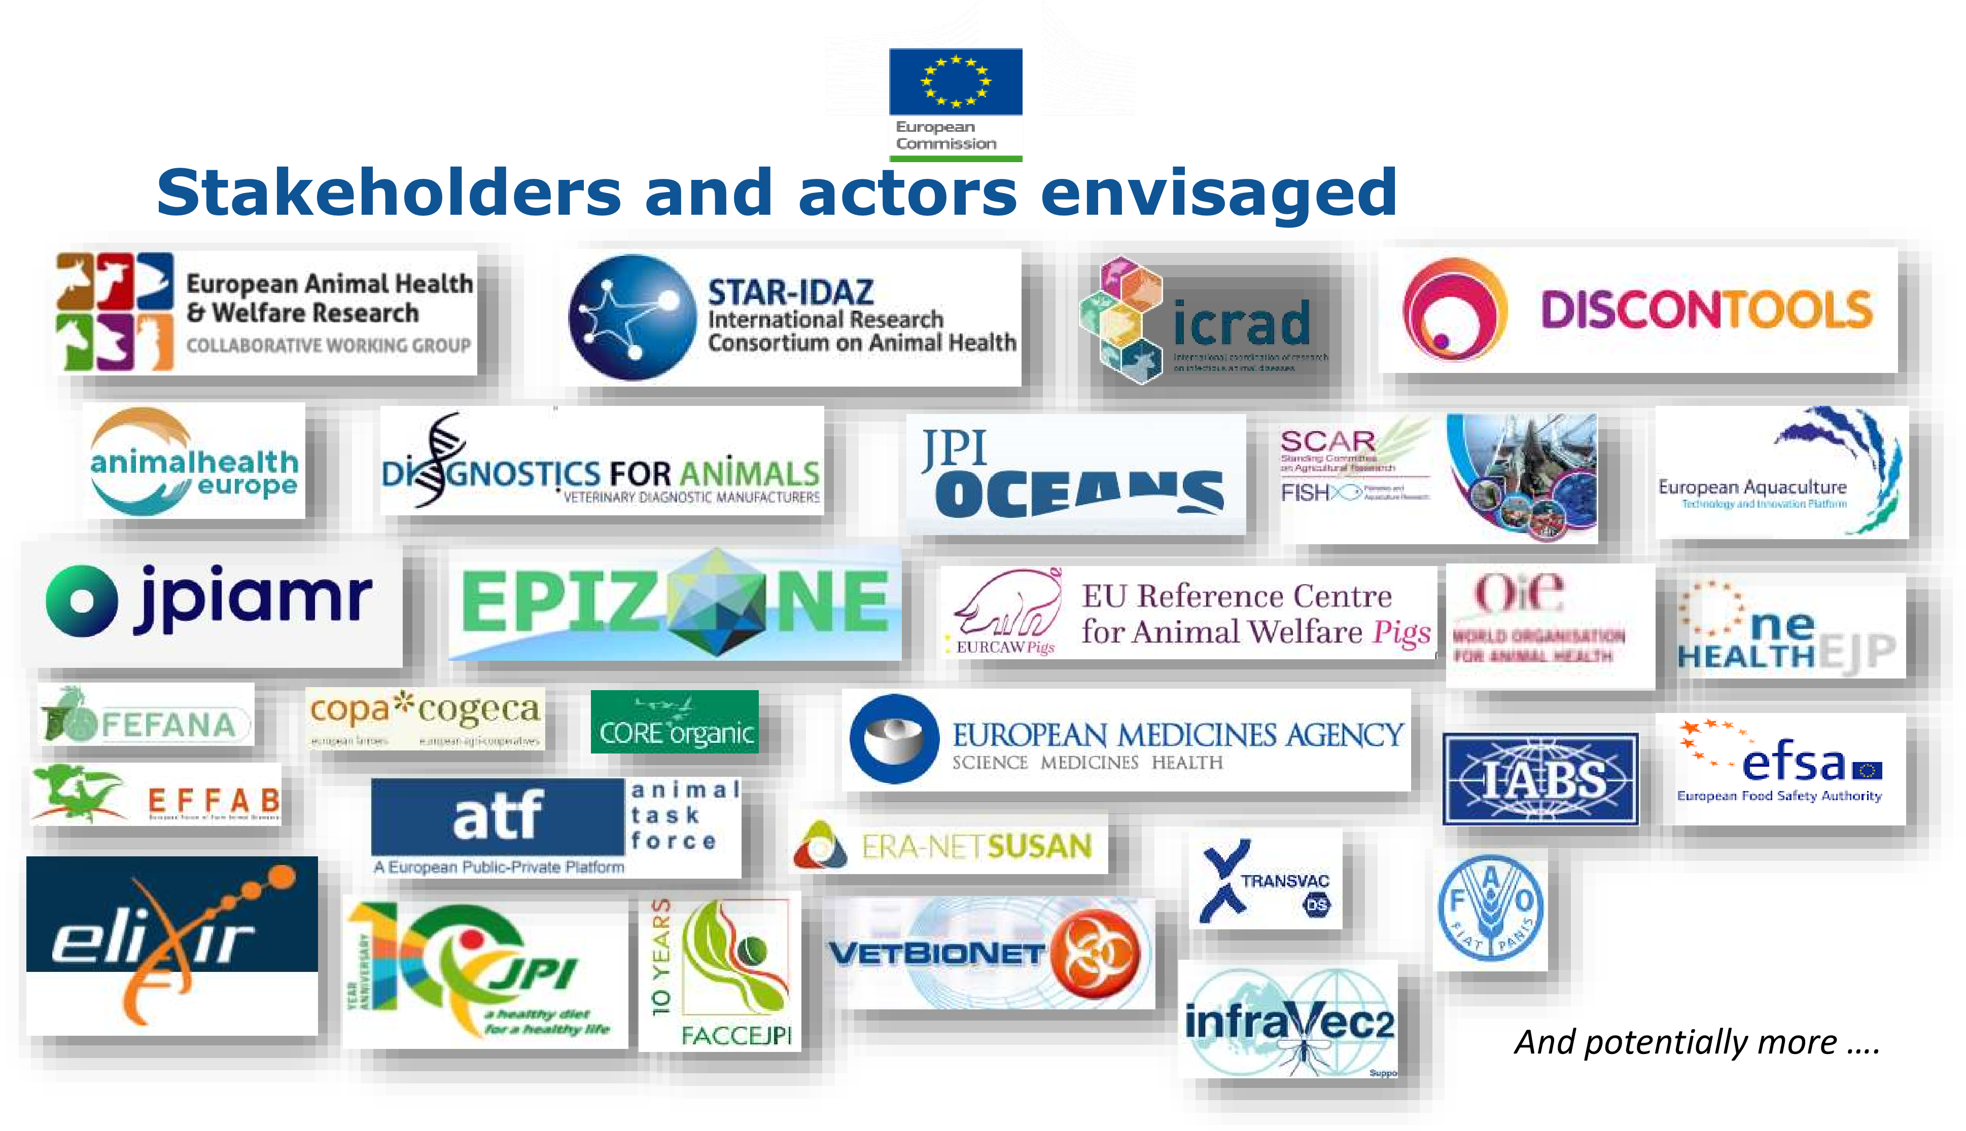
        - Other relevant stakeholders: initiatives (including other partnerships) to cooperate with agencies/authorities (e.g. EFSA, EMA, OIE.to advise)

Buts et Objectifs

- GO1 : To better control animal infectious diseases and to reinforce the preparedness of all actors
- GO2 : To place animal welfare at the foreground of animal production
SO1 : To facilitate the cooperation between all relevant actors on the monitoring, prevention and control of AID and on animal welfare issues
SO2 : To boost research and to increase the evidence-base to develop products and tools for animal health and welfare monitoring and control
SO3 : To enhance cross-sector cooperation and collaboration to prevent the spill-over from animals, food and the environment to humans in a One Health perspective
SO4 : To strengthen the communication and dissemination of project outputs to societal, political and private stakeholders
Actions:
OO1 : To design and harmonize surveillance systems for animal health and welfare
OO2 : To develop diagnostic procedures, methodologies and tools to support the monitoring of animal health
OO3 : To develop procedures, methodologies and tools to support the monitoring of animal welfare
OO4 : To adapt risk assessment and alert communication to the new needs in animal health and welfare
OO5 : To develop guidelines and preventive tools to fight against animal infectious diseases on farm
OO6 : To develop guidelines and prototype solutions that advance animal welfare on farm, during transport and at the end of life
OO7. To develop new interventions and treatments, or improve existing ones, against specific priority infectious disease of animals
OO8. To develop new vaccines or improve existing vaccines, incl. adjuvants and immune modulators
OO9. To increase access to veterinary vaccines, interventions and treatments and uptake of said vaccines interventions and treatments in the field
OO10. To study socio-economic aspects animal health and animal welfare, and how to mitigate risks
The Stakeholders Committee is composed of representatives of all stakeholder organizations. They will regularly share their expertise, advice and recommendation for inclusion in the PAHW activities.
