Workshop “Supporting the preparation of future European Partnerships" 9 - 10 March 2020- Brussels

Pre-contact:
- B. Schwartz French Research Ministry on the competition between Antimicrobial resistance project and Animal Health sector.
- Attending : ANSES , French Research Ministry, French Agriculture Ministry, INRA
- EU Level : JC Cavitte V Mariano

Manuel Aleixo DG Research and innovation Mission and Partneships Head of Unit
The meeting is clearly focus on the dialogue with members states even if some private sectors attempted.

Jean-Eric Paquet DG Research and innovation DG
specifications
- Cohérence avec le Green deal.
- More ambition, but less funding from EU (balance by imagination of cooperation)
- Need links with the others European Partnerships.
Roland Brandenburg ERA-LEARN
ERA-LEARN supports research funding organisations, policy makers and researchers with general information and services on Public-Public-Partnerships (P2Ps). We provide interested stakeholders with specific information on the implementation of joint calls, call evaluation and impact assessment as well as a broad variety of manuals, tools and workshops. On behalf of the European Commission, ERA-LEARN manages a database with information about P2P networks as well as their calls and funded projects. Learn more about the ERA-LEARN project and the Advisory Board.
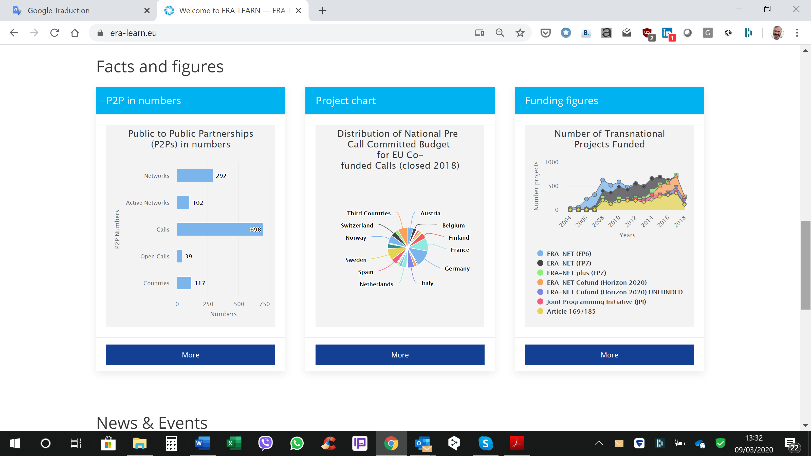
French contacts member of the Baord:
Emmanuel Pasco-Viel is a policy officer at the French Ministry of Higher Education, Research and Innovation.
Maurice Héral is in charge of international and European affairs in ANR (French National Research Agency)

Objective of the WS: Preparation of the EU Partnerships with Members States.

Focus on Candidates:

Relevant EU Partnership candidates wth likely PS participation:

One Health /AMR  Animal health | Agriculture of data  Sustainable farming

CR JLH JC Cavitte on the sidelines of the conference.

The decision phase is approaching:
- Either we remain in the current approach:
o Answers to calls
o Company by company
whereas the status quo is satisfactory
the risk in this case is to see the One Health / AMR concept fully integrate “animal health” into the next strategic agenda.
- Either we want to go further in collaboration with public partners.
In this case, the question remains of the “granulometry” of the cooperation must be clarified:
Ex: if we take the example of vaccination:
o Global approach to diseases (regulated diseases - Public / economic diseases - Private)
o Theme: Impact of vaccination on reducing the use of antibiotics
o Specific file: choose a virus
The April 29 meeting (Discontools conference) is decisive for JCC in the sense that the industry will be asked to express a clear vision of its expectations (objective of the workshop of the April the 28?).
He recommends preparing this event by a prior exchange and is at our disposal for an exchange. He is preparing a roadmap which he should send to me.
We have 2 types of resources that can be mobilized:
- The AHE innovation group (excepted the production of 9 items of interest).
- The Europe Group of RFSA which has the advantage of being composed of 2 components (public and private and of the 2 fields MV and Diagnostics) which will be exchanged on March 24.
The composition of this group should be extended to the diagnostic section.

Parallel Sessions

2 legal tools are available: Each way need to describe the deliverables.

Co-programs: (steering by member states – calls - without any European funds being paid directly.)  - for the diagnosis the deal could be to redirect the budgets spent on controls (administrative burden) in the different national member states towards a list of innovation themes jointly considered as priorities.  - For the vét.med the deal could be to divide up the fields: private industry - economic diseases, States - regulated diseases | Co-Funding:  - eg: EJP One Health  - the concrete impact of the road map has to be described.  - Private sector is involved in kind or in cash.

The most interesting initiatives for us was:

- https://faccejpi.net/
FACCE-JPI brings together 24 countries comprised of EU Member States, associated countries and one Third Country (New Zealand) who are committed to building an integrated European Research Area addressing the interconnected challenges of sustainable agriculture, food security and impacts of climate change.
By providing and steering research FACCE-JPI supports sustainable agricultural production and economic growth, to contribute to a European bio-based economy, while maintaining and restoring ecosystem services under current and future climate change.
The aim is to do so with a strong transdisciplinary research base, encompassing economic and social aspects in addition to scientific ones, and with a creative approach towards the alignment of national programmes and the input of multiple actors and stakeholders.

Unfortunately, this platform will be dispatched in different program.

- https://www.biodiversa.org/396

BiodivERsA - the network programming and funding research on biodiversity and ecosystem services across European countries and territories
BiodivERsA is a network of 39 agencies and ministries from 25 European countries and associated countries programming and funding pan-European research on biodiversity and ecosystem services on a competitive basis. It is an ERA-NET Co-fund, funded under the EU’s Horizon 2020 Framework Programme for Research and Innovation.

Day 2 10/03/20
https://www.era-learn.eu/

Coherence of the partnerships landscape and relevance for the political priorities of the new commission. Angus Hunter OPTIMAT
Report: Impact assessment study for institutionalized European Partnerships under horizon Europe.

Animal Health is always linked with the One Health concept.
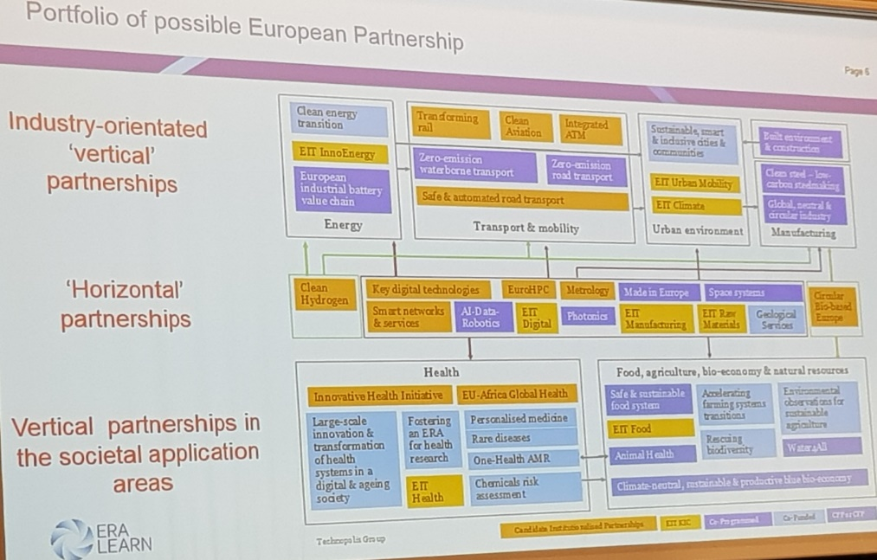

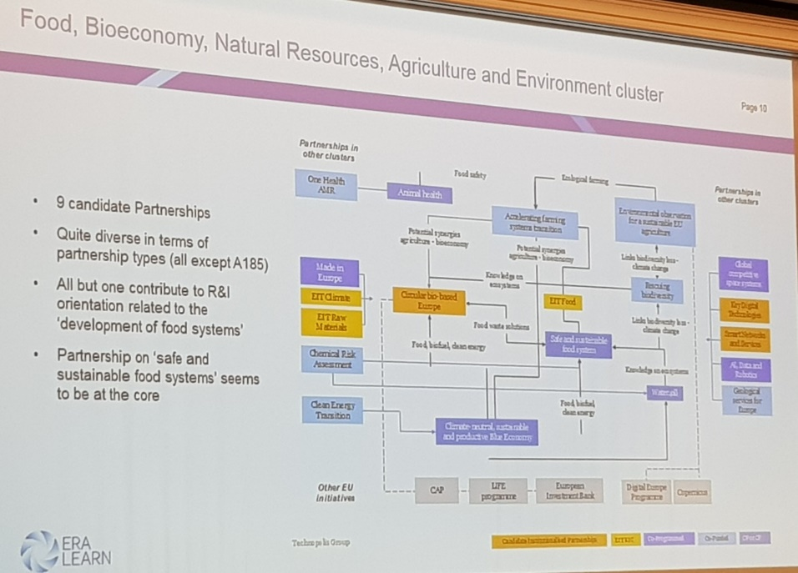
Le letter of candidacy has to be sent before this summer from the member states to the Commission (financial contribution).

Criteria for EU Partnerships

Annexe 1 Types of Partnerships
- Joint Programming Initiatives (JPIs)
- Article 185 Initiatives
- ERA-NET Scheme
- European Joint Programme Cofund (EJP Cofund)
- Public-Private Partnerships
- Other ERA relevant Partnership Initiatives
add to pdf
Over the past years there has been a proliferation of instruments and initiatives oriented towards coordination, collaboration, and even alignment of national strategies and programmes in further developing the ERA. These instruments have aimed at tackling societal challenges while also strengthening European competitiveness. They span from either Member State-lead initiatives to instruments strongly supported by the European Commission (Public to Public Partnerships, P2Ps), or from partnerships among public agencies to alliances between the public and private sectors (Public-Private Partnerships, PPPs).
ERA-LEARN has a focus on Public-Public-Partnerships (P2P). Nevertheless an overview on other ERA coordination instruments is given.

Public- Public Partnerships (P2Ps) in research and innovation
Public-Public Partnerships (P2Ps) in research and innovation are networks of public organisations (Ministries, funding agencies, programme managers) from interested EU countries and beyond, that join forces to support research activities under an agreed vision or research and innovation agenda. In this way, these partnerships align national strategies, helping to overcome fragmentation of public research effort. Public-public partnerships include networks supported by the European Commission such as ERA-NETs and Art 185s as well as Member State-led initiatives, the Joint Programming Initiatives.

Joint Programming Initiatives (JPIs)
Joint Programming is a structured and strategic process whereby Member States agree, on a voluntary basis and in a partnership approach, on common visions and Strategic Research Agendas (SRA) to address major societal challenges.

Art. 185 initiatives
Article 185 (former Article 169) initiatives are multiannual programmes jointly implemented by several EU Member States and Associated Countries. The European Union participates by providing a significant financial contribution through the Framework Programme.

ERA-NET Cofund
Under Horizon 2020, the ERA-NET Cofund strengthens the cooperation between national/ regional public organizations. They implement joint activities and organise one substantial joint project call with top-up funding from the Commission.

EJP Cofund
EJP Cofund, a new instrument under Horizon 2020, supports the implementation of a joint programme of activities over a period of 5 years, including research but also coordination, networking, training, etc.

Public-Private Partnerships (PPPs) in research and innovation
Two different types of Public-Private Partnerships (PPPs) are implemented under Horizon 2020:

Joint Undertakings (JUs) / Joint Technology Initiatives (JTIs)
The Joint Undertakings (JUs) or otherwise known as Joint Technology Initiatives (JTIs) that are PPPs in industrial research at European level. JUs organise their own R&I agendas and award Horizon 2020 funding for projects on the basis of competitive calls.

Contractual Public-Private Partnerships (cPPP)
The Contractual Public-Private Partnerships (cPPP) that involve dedicated arrangements between the Commission and private associations representing the interest of industrial technologies. Funding for research is awarded by the Commission through open calls under the Horizon 2020 Work Programme.

