Forward agenda

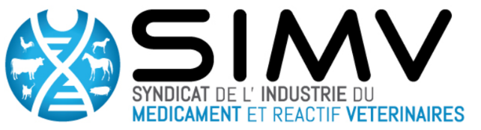

27 September 2017 – 2:00 pm to 5:30 pm

2pm | Welcome and introduction from the Pastor Institute and the SIMV  Pierre Legrain (Head of Development Department) and Catherine Charreyre (SIMV / Merial-Boehringer)
2:05 pm to 2:30 | Presentation of the veterinary sector and the development of new veterinary medicinal products - by the SIMV  - Market of a veterinary medicinal products and veterinary drugs development  Pascal Raoul (SIMV / CEVA) - Director Innovation and Science Biology  - Specific animal drug development needs for a veterinary SMEs  Olivier Charpiat (SIMV / TVM) General Manager at TVM Laboratories & Vice-Président SIMV  - Specific veterinary diagnostic industries needs  SERGE Leterme (SIMV/ Idexx) - Head of Research & Development and Operations, Worlwide, for Livestock, Poultry and Dairy Diagnostic Products
2:30 pm to 3:15 pm | Round table 1 : Diagnostics  - Veterinary industry point of view : Success story of Schmallenberg diagnostic tests  Philippe Pourquier (SIMV/Idvet) - CEO at IDvet  - Cooperation and collaboration possibilities in the veterinary diagnostic field: concrete examples at the Institut Pasteur  E. Brient-Litzler (Directrice adjointe du Centre d’Innovation et de Recherche Technologique (CITECH) – Institut Pasteur Paris) ; P. Bourhy (Unité de Biologie des Spirochètes – Institut Pasteur Paris) ; R. Jambou (Département de Parasitologie Mycologie – Institut Pasteur de Côte-d’Ivoire)  Philippe Pourquier (SIMV- Idvet) - CEO at IDvet ; SERGE Leterme (SIMV -Idexx) - Head of Research & Development and Operations, Worlwide, for Livestock, Poultry and Dairy Diagnostic Products
3 :15 pm to 4 :00 pm | Round Table 2 : Antibiotic resistance  - What innovative solutions to antimicrobial resistance ? - Philippe Glaser (Unité Ecologie et évolution de la Résistance aux Antibiotiques)  - Possible cooperation paths and collaborations  Philippe Glaser (Unité Ecologie et évolution de la Résistance aux Antibiotiques), Gérard- Marie Papierok (SIMV / Virbac), Public research and clusters partnership Manager ; Bertrand Ridremont (SIMV/MSD Santé animale) Technical Director BU Ruminants ; Marie-Anne BARTHELEMY (SIMV) General Secretary of the SIMV
4:00 pm  to 4:15 pm | Break
4:15 pm  to 5:00 pm | Round Table 3 : Vaccines  - Veterinary vaccine industry overview : Success story of Bluetongue vaccines - Pascal Hudelet (SIMV/BI), Head, Technical Services, the Veterinary Public Health Center – to confirm  - How veterinary vaccine industries and Pasteur Institute might collaborate in vaccinology ? Christiane Gerke (Head of Vaccine Programs, Development Department - Institut Pasteur Paris) ; Philippe Jeannin – (SIMV/BI) Chief Technical Officer
5:00 to 5:25 pm | General conclusions  - R&D Dating for Animal Health and Innovation presentation- Claire Brugerolles (SIMV)  - Mechanisms for cooperation & Incentive Programs at the Pasteur Institute  - Intervention of the International Network of Pasteur Institute
5:25 pm  to 5:30 pm | Final statements  Pierre Legrain, Jean-Louis Hunault
Cocktail

